* Html headings
* Links
* Images
* Images as link
* List ,nested list
* Table rowspan column span
* Form: method attributes, action attributes
* Form input types , required fields
* Responsive pages
* Css position
* Overflow
* Combinators
* Selectors
* Maxwidth height
* Practice quiz 1 questions
* Mid questions

Html attributes

Attributes provides additional information about elements, attributes are always specified in the starting tag.

* All HTML elements can have attributes
* The href attribute of <a> specifies the URL of the page the link goes to-

E.g <a href=”[www.w3school.com](http://www.w3school.com)> welcome to the w3school!</a>

* The src attribute of <img> specifies the path to the image to be displayed

E.g- <img src=”/images/img_girl.jpg”>

there are two ways to specify the URL in the src attribute:

1. Absolute URL - Links to an external image that is hosted on another website. Example: src="https://www.w3schools.com/images/img_girl.jpg".

Notes: External images might be under copyright. If you do not get permission to use it, you may be in violation of copyright laws. In addition, you cannot control external images; it can suddenly be removed or changed.

2. Relative URL - Links to an image that is hosted within the website. Here, the URL does not include the domain name. If the URL begins without a slash, it will be relative to the current page. Example: src="img_girl.jpg". If the URL begins with a slash, it will be relative to the domain. Example: src="/images/img_girl.jpg".

Tip: It is almost always best to use relative URLs. They will not break if you change domain.

* The width and height attributes of <img> provide size information for images

E.g- <img src=”/images/img_girl.jpg” width=500 height=500>

* The alt attribute of <img> provides an alternate text for an image if the image for some reason cannot be displayed.This can be due to a slow connection, or an error in the src attribute, or if the user uses a screen reader.

E.g- <img src=”/images/img_girl.jpg” width=500 height=500 alt=”girl with a jacket”>

* The style attribute is used to add styles to an element, such as color, font, size, and more

E.g: <p style=”color:red”> this is a red paragraph</p>

## HTML Headings

HTML headings are defined with the <h1> to <h6> tags.

<h1> defines the most important heading. <h6> defines the least important heading.

Note: Browsers automatically add some white space (a margin) before and after a heading.

## Bigger Headings

Each HTML heading has a default size. However, you can specify the size for any heading with the style attribute, using the CSS font-size property:

E.g- <h1 style=”font size:60px”> this is abig heading than h1!</h1>

# 

# HTML Paragraphs

## HTML Tag Reference

W3Schools' tag reference contains additional information about HTML elements and their attributes.

| **Tag** | **Description** |
| --- | --- |
| [<p>](https://www.w3schools.com/tags/tag_p.asp) | Defines a paragraph |
| [<hr>](https://www.w3schools.com/tags/tag_hr.asp) | Defines a thematic change in the content |
| [<br>](https://www.w3schools.com/tags/tag_br.asp) | Inserts a single line break |
| [<pre>](https://www.w3schools.com/tags/tag_pre.asp) | Defines pre-formatted text |

A paragraph always starts on a new line, and browsers automatically add some white space (a margin) before and after a paragraph.

With HTML, you cannot change the display by adding extra spaces or extra lines in your HTML code.The browser will automatically remove any extra spaces and lines when the page is displayed-

<p>

This paragraph

contains a lot of spaces

in the source code,

but the browser

ignores it.

</p>

## HTML Horizontal Rules

The <hr> tag defines a thematic break in an HTML page, and is most often displayed as a horizontal rule.

The <hr> element is used to separate content (or define a change) in an HTML page

E,g- <h1> this is a heading </h1>

<p> this is a paragraph and underneath of this para there will be an horizontal ruler</p>

<hr>

## HTML Line Breaks

The HTML <br> element defines a line break.

Use <br> if you want a line break (a new line) without starting a new paragraph:

E.g- <p> this is a paragraph with <br> line breaks </p>

## The HTML <pre> Element

**The HTML <pre> element defines preformatted text.**

**The text inside a <pre> element is displayed in a fixed-width font (usually Courier), and it preserves both spaces and line breaks:**

**<pre>**

**My Bonnie lies over the ocean.**

**My Bonnie lies over the sea.**

**My Bonnie lies over the ocean.**

**Oh, bring back my Bonnie to me.**

**</pre>----> it will be displayed like the way it is written within the pre tag with defined line spaces and everything!**

# 

# HTML Styles

## 

<body>

<h1 style="background-color:powderblue;text-align:center">This is a heading</h1>---->this is also put the heading in the center

<p style="background-color:tomato;">This is a paragraph.</p>

</body>

## Border Color

You can set the color of borders:

## Hello World

## Hello World

## Hello World

### Example

<h1 style="border:2px solid Tomato;">Hello World</h1>

<h1 style="border:2px solid DodgerBlue;">Hello World</h1>

<h1 style="border:2px solid Violet;">Hello World</h1>

## 

## Chapter Summary

* **Use the style attribute for styling HTML elements**
* **Use background-color for background color**
* **Use color for text colors**
* **Use font-family for text fonts**
* **Use font-size for text sizes**
* **Use text-align for text alignment**

# HTML text formatting elements

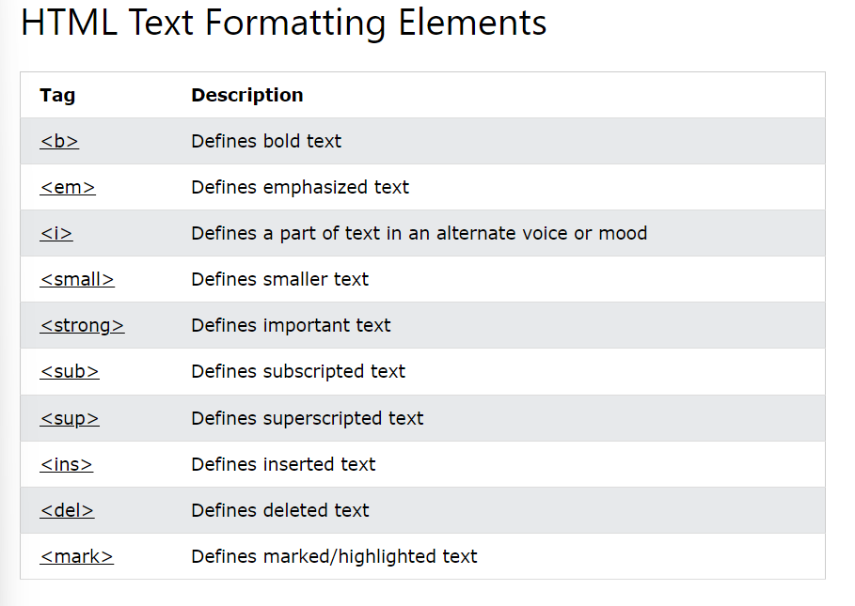

## 

## 

## 

## 

## 

## HTML Links

## Chapter Summary

* Use the <a> element to define a link
* Use the href attribute to define the link address
* Use the target attribute to define where to open the linked document
* Use the <img> element (inside <a>) to use an image as a link
* Use the mailto: scheme inside the href attribute to create a link that opens the user's email program

e.g-> <a href=”<mailto:zannatulelma@gmail.com>”> send elmo an email</a>

## HTML Links - The target Attribute

## By default, the linked page will be displayed in the current browser window. To change this, you must specify another target for the link.

## The target attribute specifies where to open the linked document.

## The target attribute can have one of the following values:

## _self - Default. Opens the document in the same window/tab as it was clicked

## _blank - Opens the document in a new window or tab

## _parent - Opens the document in the parent frame

## _top - Opens the document in the full body of the window

E.g– <a href=”[www.w3school.com](http://www.w3school.com)” target=”_blank”> visit w3school!</a>

## Absolute URLs vs. Relative URLs

Both examples above are using an absolute URL (a full web address) in the href attribute.

A local link (a link to a page within the same website) is specified with a relative URL (without the "https://www" part):

### Example

<h2>Absolute URLs</h2>

<p><a href="https://www.w3.org/">W3C</a></p>

<p><a href="https://www.google.com/">Google</a></p>

<h2>Relative URLs</h2>

<p><a href="html_images.asp">HTML Images</a></p>

<p><a href="/css/default.asp">CSS Tutorial</a></p>

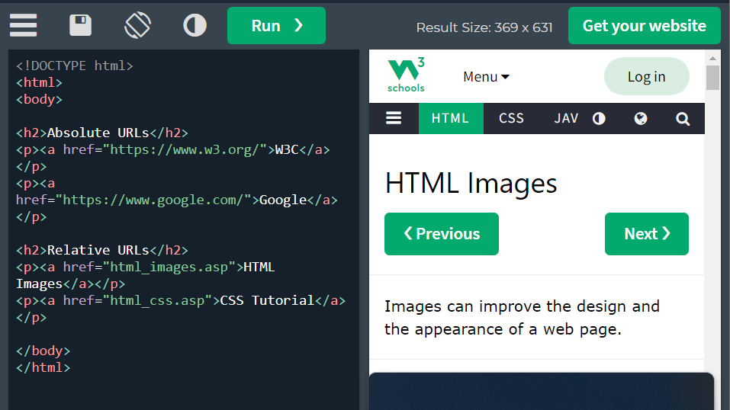

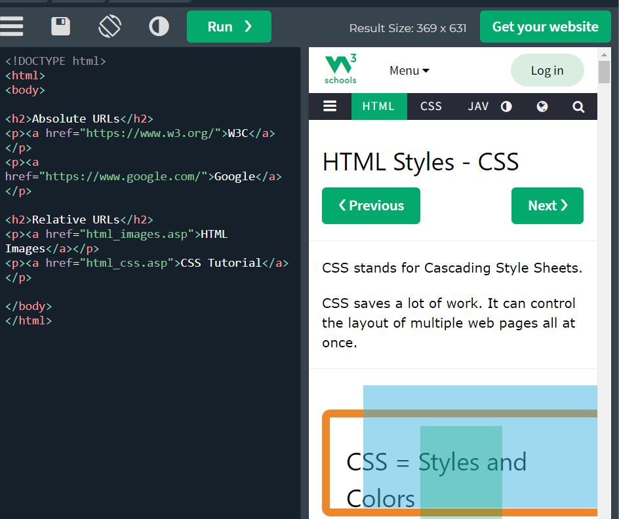

## 

## HTML Links - Use an Image as a Link

To use an image as a link, just put the <img> tag inside the <a> tag:

E.g-

<a href=”default.asp”>----link to the html tutorial

<img src=”smiley.gif” alt=”html tutorial” style=”width:42px;height:42px;”></a>

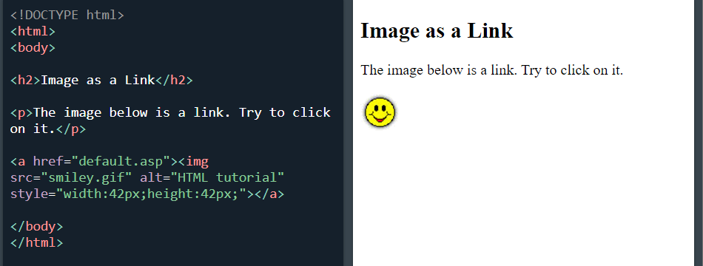

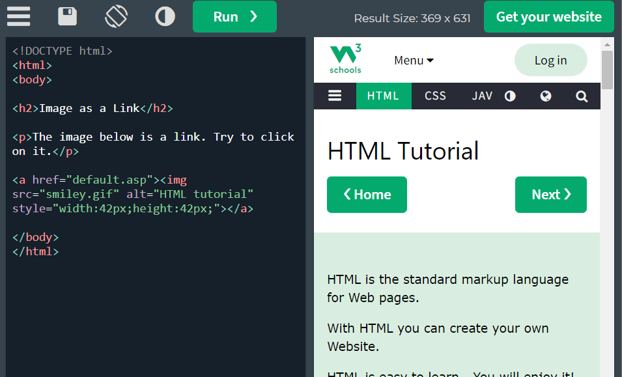

## Link Titles

The title attribute specifies extra information about an element. The information is most often shown as a tooltip text when the mouse moves over the element.

<a href=”w3school.com” tittle=”go to w3school html section”> visit our html tutorial</a>

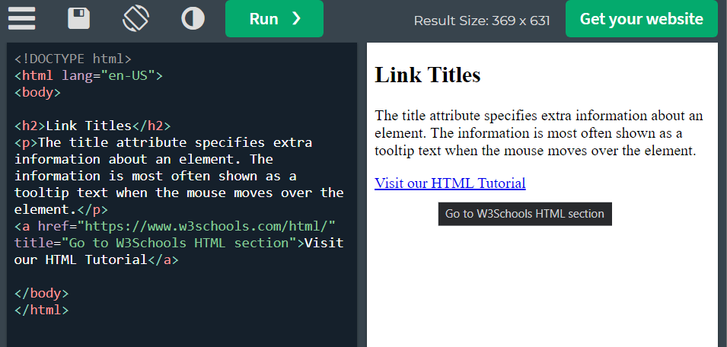

## Link Titles

## Chapter Summary

* Use the HTML <img> element to define an image
* Use the HTML src attribute to define the URL of the image
* Use the HTML alt attribute to define an alternate text for an image, if it cannot be displayed
* Use the HTML width and height attributes or the CSS width and height properties to define the size of the image
* Use the CSS float property to let the image float to the left or to the right

# HTML Tables

## HTML Table Tags

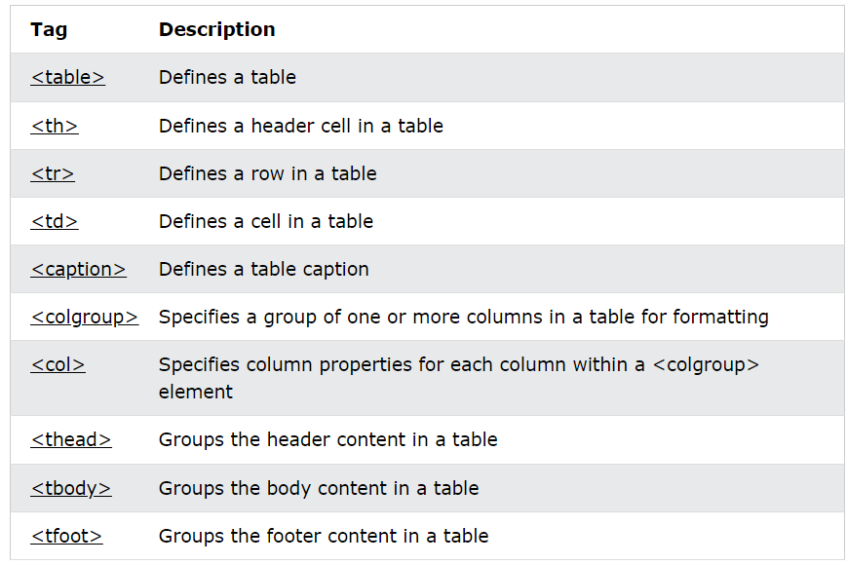

Table borders:

## 

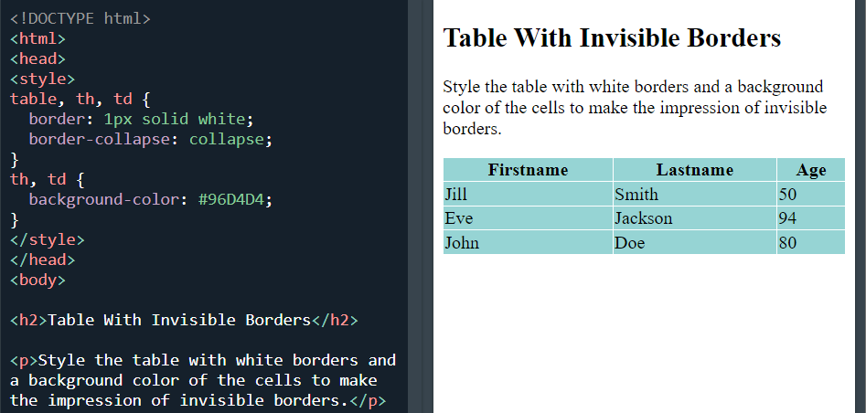

## 

Table padding:

When the padding is 0px.

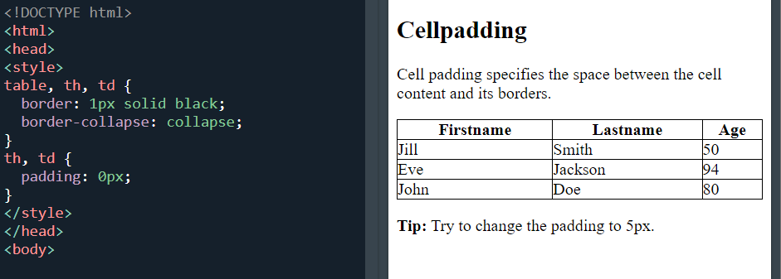

When padding is 15 px

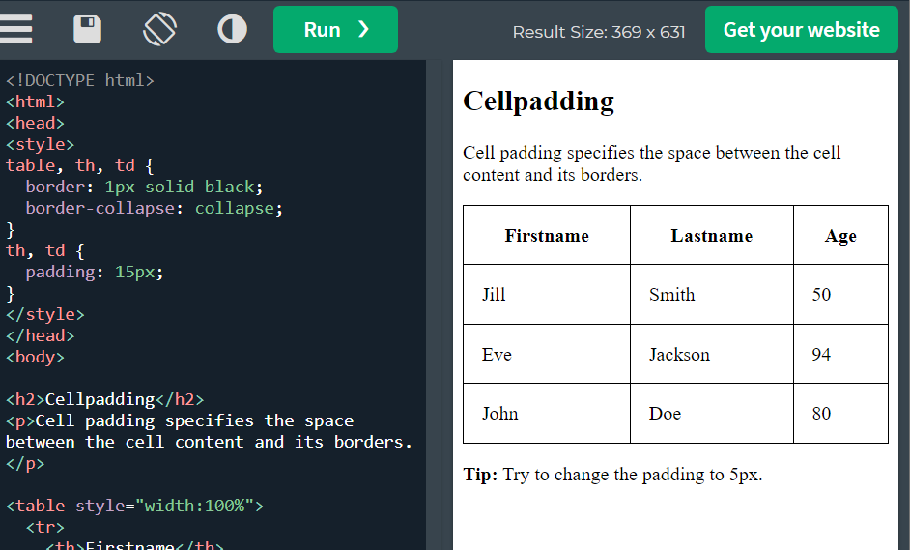

Cell spacing:

When spacing is set to 0px

**** it will be the same if we dont use border space and instead use this-

table, th, td {

border: 1px solid black;

border-collapse:collapse;

}

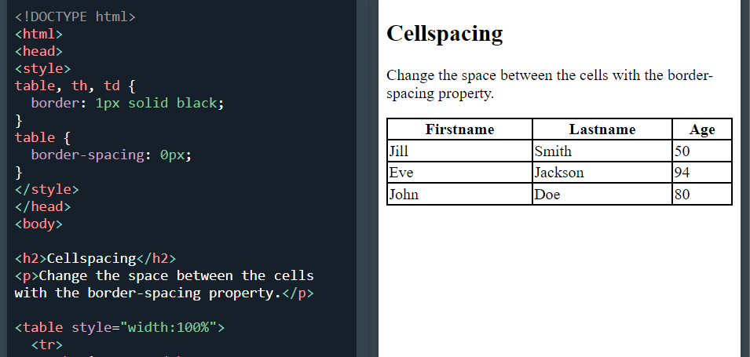

—- when using border-spacing of 15 px

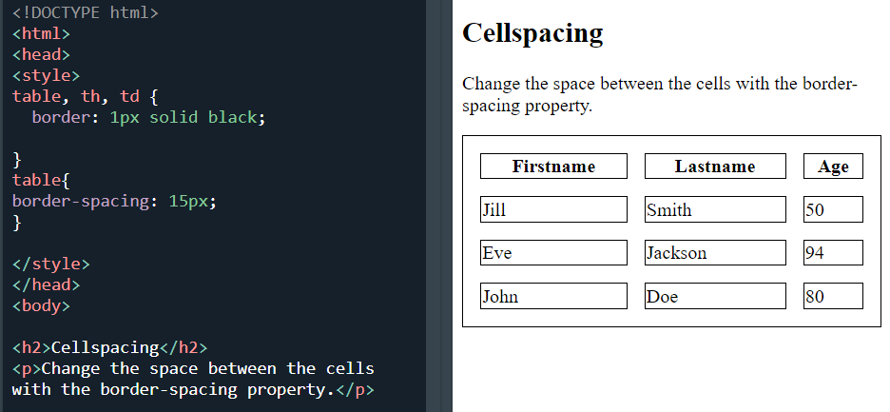

Rowspan colspan

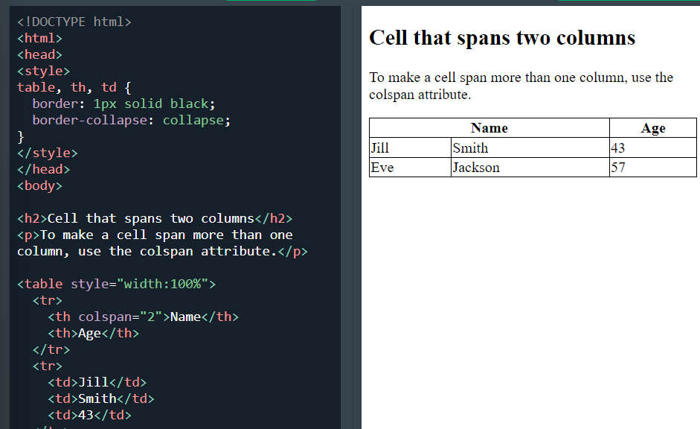

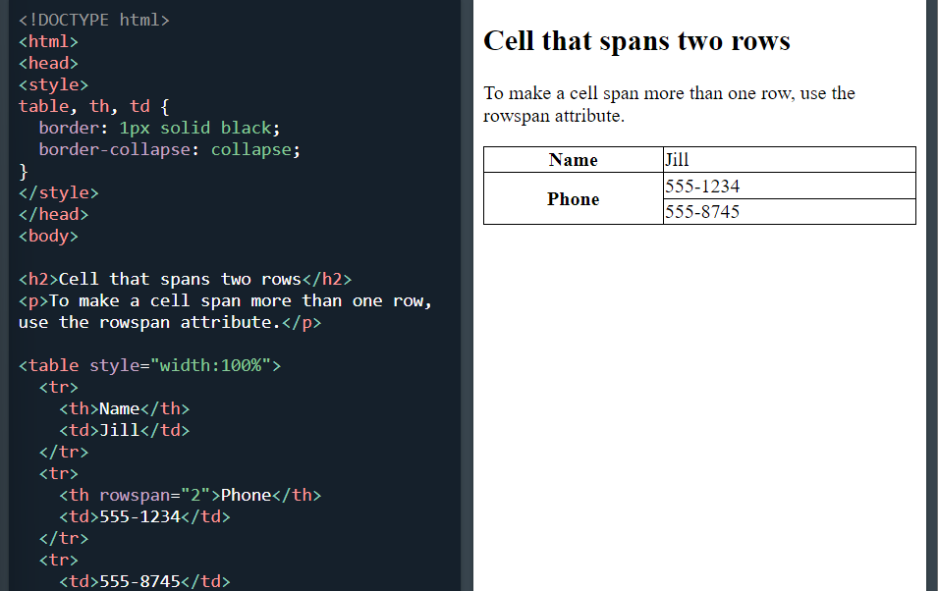

## HTML List Tags

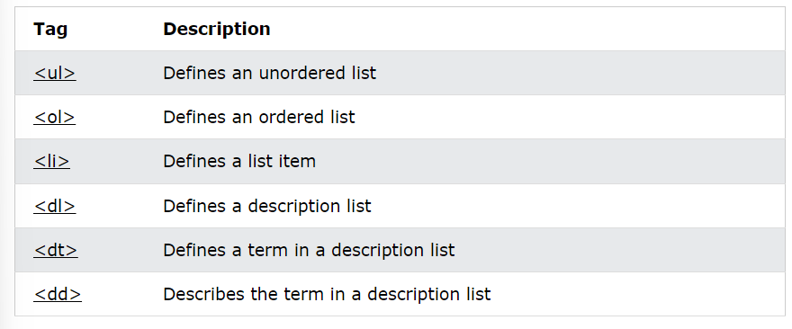

## 

## Chapter Summary

## 

* Use the HTML <ul> element to define an unordered list
* Use the CSS list-style-type property to define the list item marker
* Use the HTML <li> element to define a list item
* Lists can be nested
* List items can contain other HTML elements
* Use the CSS property float:left to display a list horizontally
* Use the HTML <dl> element to define a description list
* Use the HTML <dt> element to define the description term
* Use the HTML <dd> element to describe the term in a description list

E.g-

<dl>

<dt>Coffee</dt>

<dd>-black hot drink</dd>

<dt>Milk</dt>

<dd>-white cold drink<dd>

</dl>

## Unordered list

The CSS list-style-type property is used to define the style of the list item marker. It can have one of the following values:

<ul style=”list-style-type:square;”>

<li>coffee</li>

<li>tea</li>

</ul>

## 

## Horizontal List with CSS

HTML lists can be styled in many different ways with CSS.

One popular way is to style a list horizontally, to create a navigation menu:

### Example

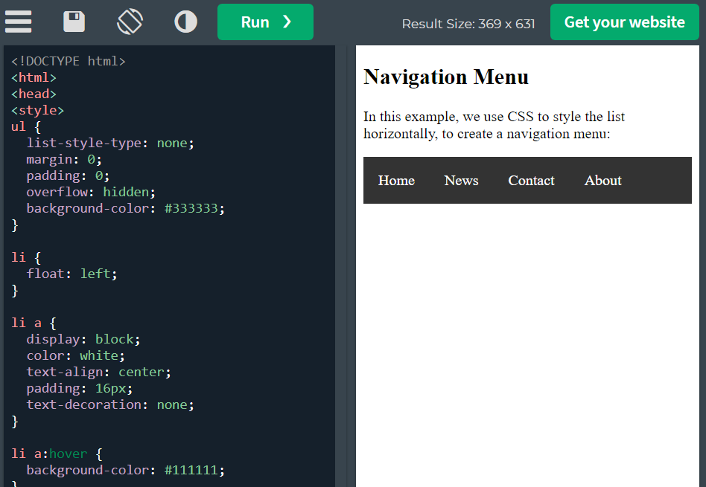

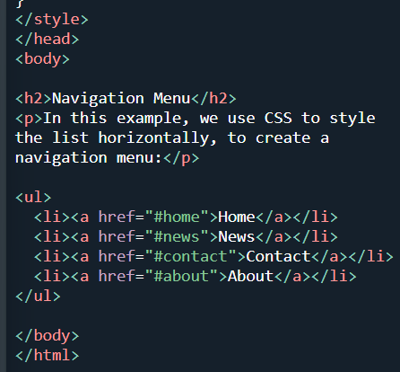

## 

## Ordered HTML List

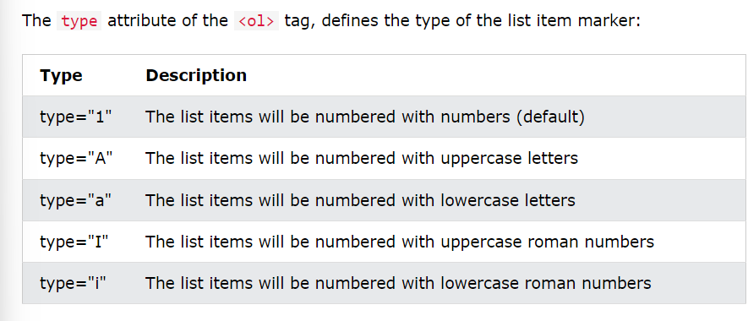

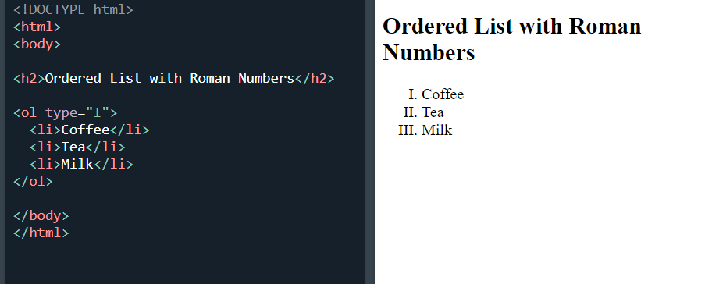

## Control List Counting

By default, an ordered list will start counting from 1. If you want to start counting from a specified number, you can use the start attribute:

<ol start="50">

<li>Coffee</li>

<li>Tea</li>

<li>Milk</li>

</ol>

## 